HR ANALYTICS DASHBOARD: POWER BI

**1. Description**

The HR attrition analytics project focuses on analyzing employee turnover using Power BI. The primary goal is to uncover key factors contributing to attrition based on various attributes such as age group, education, tenure, job role, salary, and gender. The project involves data preparation, processing, visualization, and generating actionable insights to help HR teams reduce attrition rates.

**2. Plan**

The analytics plan follows a structured approach:

* **Define Objectives**: Understand the reasons for employee attrition and identify potential retention strategies.
* **Identify Data Sources**: Employee demographic data, job-related details, and salary information.
* **Determine Metrics**: Attrition rate, attrition by job role, salary, gender, education, tenure, and department.
* **Select Tools**: Power BI is chosen for data visualization and analysis.
* **Create Dashboard**: Develop interactive visualizations for HR decision-making.

**3. Prepare**

* **Data Collection**: Import employee attrition data into Power BI.
* **Data Cleaning**: Handle missing values, remove duplicates, and ensure consistency in format.
* **Data Transformation**: Use Power Query for data formatting, categorization, and creating calculated columns.
* **Data Enrichment**: Apply derived measures using DAX (Data Analysis Expressions) to enhance insights.

**4. Process**

* **Data Modeling**: Establish relationships between different attributes such as department, tenure, salary, and attrition status.
* **DAX Calculations**: Create calculated columns and measures to analyze attrition trends.
* **Filtering & Segmentation**: Use slicers and filters to segment data based on specific demographics.
* **Data Aggregation**: Compute attrition percentages for various categories.

**5. Analyze**

The key aspects of analysis include:

* **Attrition by Age Group**: Identifies which age groups have the highest turnover.
* **Attrition by Education**: Determines whether education levels impact employee retention.
* **Attrition by Tenure**: Finds trends in employee exit rates based on years of service.
* **Attrition by Job Role**: Highlights specific roles with high attrition.
* **Attrition by Salary Slab**: Analyzes whether salary influences employee turnover.
* **Attrition by Gender**: Assesses differences in attrition rates between male and female employees.

**6. Insights & Key Findings**

**1. Age-Based Attrition**

* Younger employees (early career professionals) show the highest attrition rates.
* Mid-career employees have relatively stable retention, while late-career professionals exhibit lower attrition.

**2. Education & Attrition**

* Employees with only a high school diploma tend to have higher attrition than those with graduate degrees.
* Higher education correlates with lower attrition, possibly due to better job stability.

**3. Tenure-Based Attrition**

* Most attrition occurs within the first 2-3 years of employment, indicating potential onboarding or work culture issues.
* Employees with 5+ years of tenure have significantly lower attrition rates.

**4. Job Role Impact**

* Certain job roles experience higher turnover, particularly in entry-level or operational positions.
* High attrition in specific roles may indicate job dissatisfaction or lack of career growth opportunities.

**5. Salary & Attrition**

* Employees in lower salary slabs tend to leave more frequently, highlighting the importance of competitive compensation.
* Higher salary slabs show better retention rates, suggesting financial incentives as a strong motivator.

**6. Gender-Based Analysis**

* Attrition rates among male and female employees are relatively balanced, but certain departments show gender-specific trends.
* Work-life balance and flexible policies may play a role in retention for different genders.

**7. Share**

* **Dashboard Creation**:
  + Interactive Power BI visualizations such as bar charts, pie charts, and trend lines.
  + Filters and slicers to allow dynamic exploration of data.
  + Custom measures to display real-time attrition insights.
* **Report Distribution**:
  + Exporting the Power BI dashboard as a PDF or embedding it in HR reports.
  + Sharing interactive dashboards with HR teams for strategic planning.

**8. Act**

Based on the findings, the following strategies can be implemented:

* **Retention Strategies**: Focus on engaging younger employees and those in high-turnover roles.
* **Salary Adjustments**: Competitive pay structures for lower-salary groups to reduce attrition.
* **Training & Development**: Provide career growth opportunities for employees at risk of leaving.
* **Diversity & Inclusion Initiatives**: Address role-specific gender disparities.
* **Employee Engagement Programs**: Improve work-life balance, culture, and career development support.

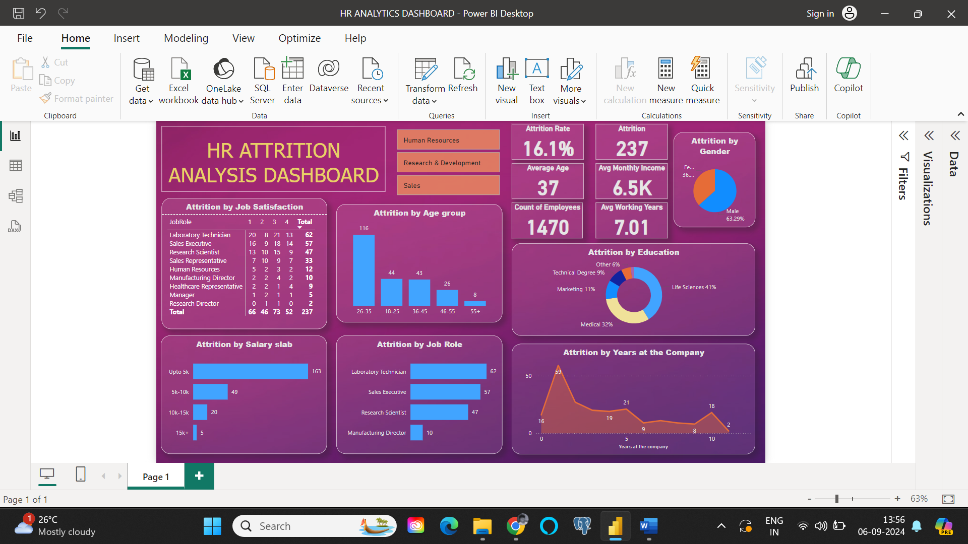

1. Attrition by age group:



1. Attrition by Education:



1. Attrition by Years at the company:



1. Attrition by Job role:

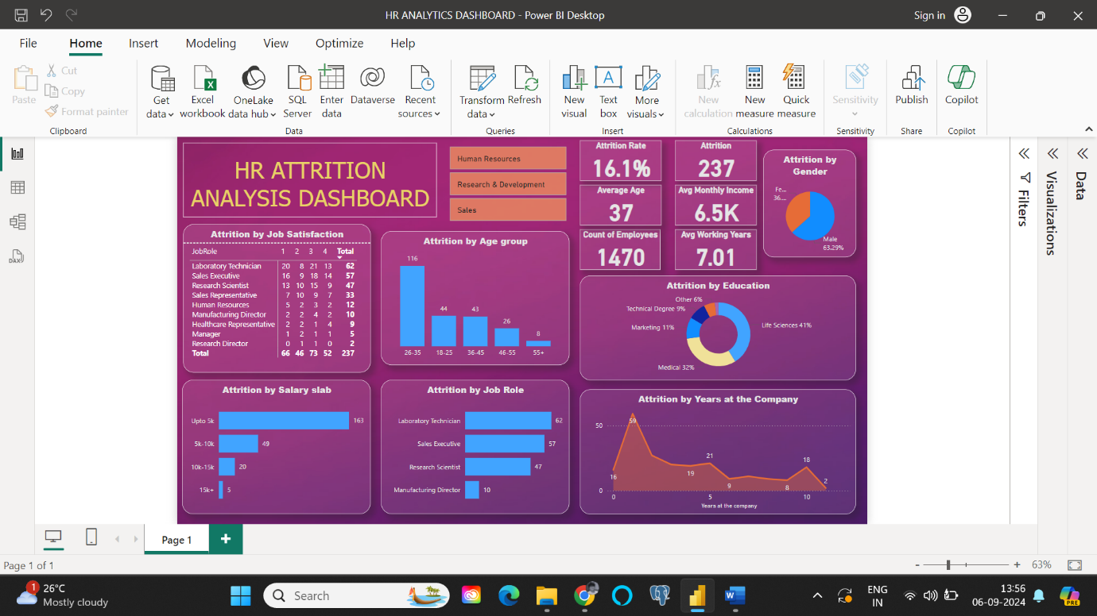

1. Attrition by Salary slab:



1. Attrition by Gender:

